Experiment: 1
Aim:
To write a Python program to solve the 8-Puzzle problem by moving the blank tile (0) to reach the goal state.
Algorithm:
- Start the program.
- Initialize the initial state and goal state.
- Find the position of the blank tile (0).
- Check whether the blank tile can move to the right.• If possible, swap the blank tile with the tile on its right.
- Display the initial state and the next state.
- Check whether the goal state is reached.
- Stop the program.
Code: 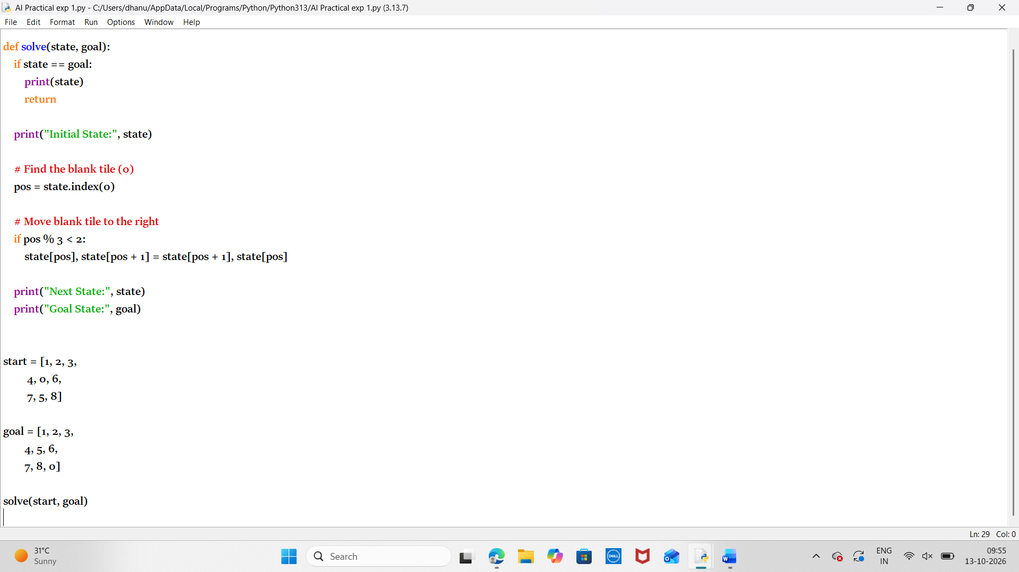
Output: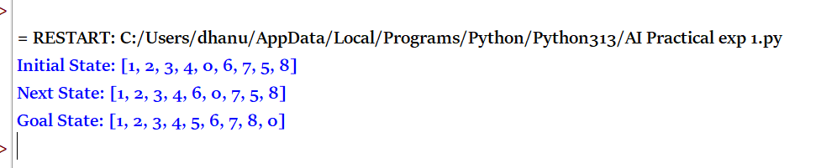

Result:
Thus the python program to solve the 8 puzzle program is executed successfully.

